[E126] Power button

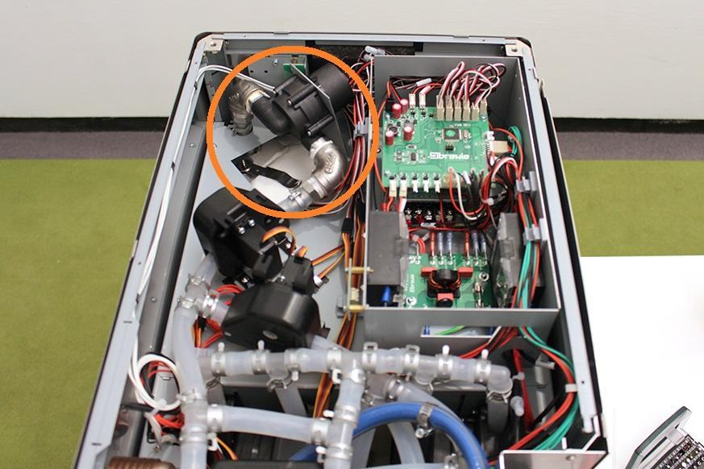

Remove the cable tie.

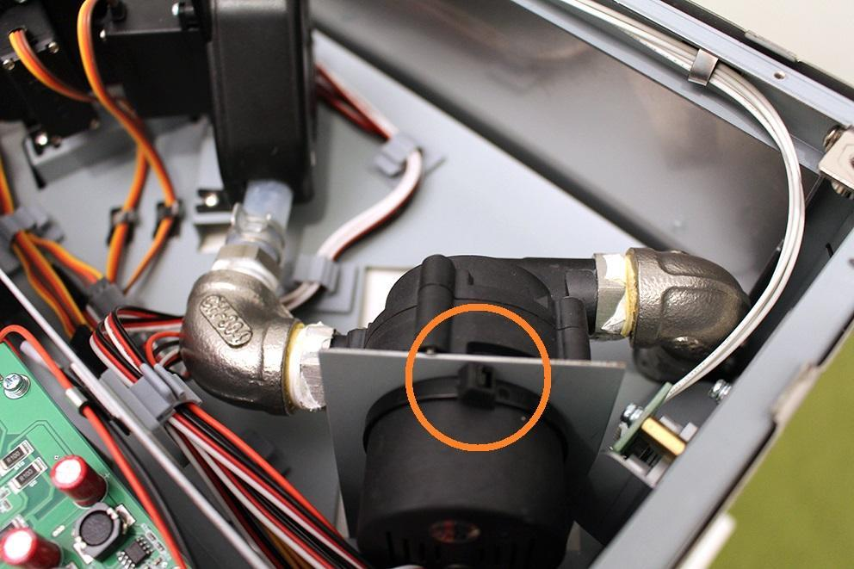

Loosen the screws of the valve next to the pump and remove the valve from its original position in order to the easier assembling.

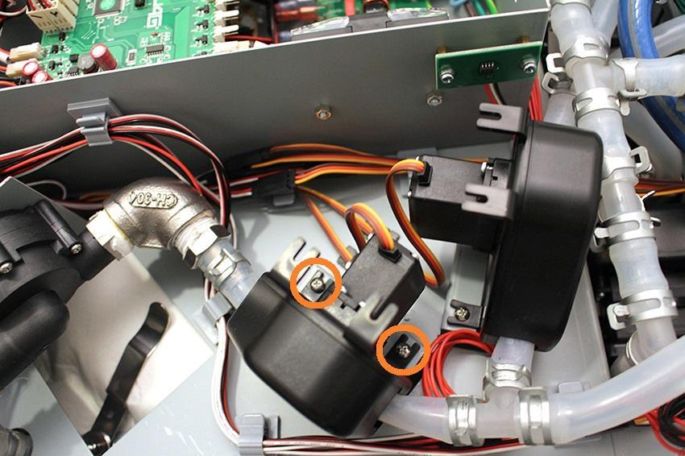

Pull off the hose clamp from the fitting.

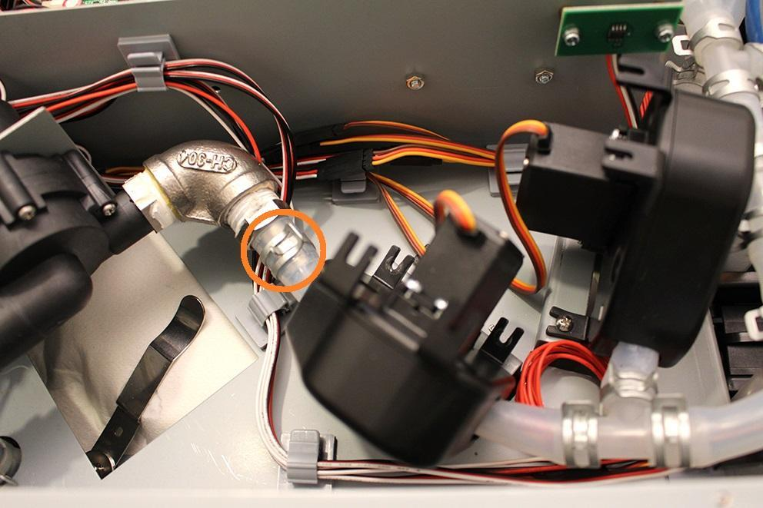

Pull off the silicone tube.

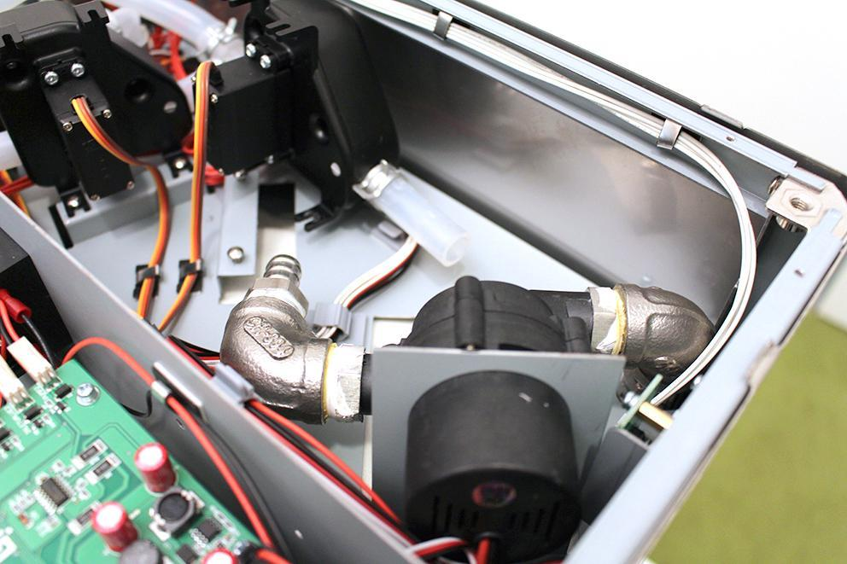

While you keep the indicated hose clamp tightly, you can pull off the pump from the silicone tube by rotating the pump around its axis.

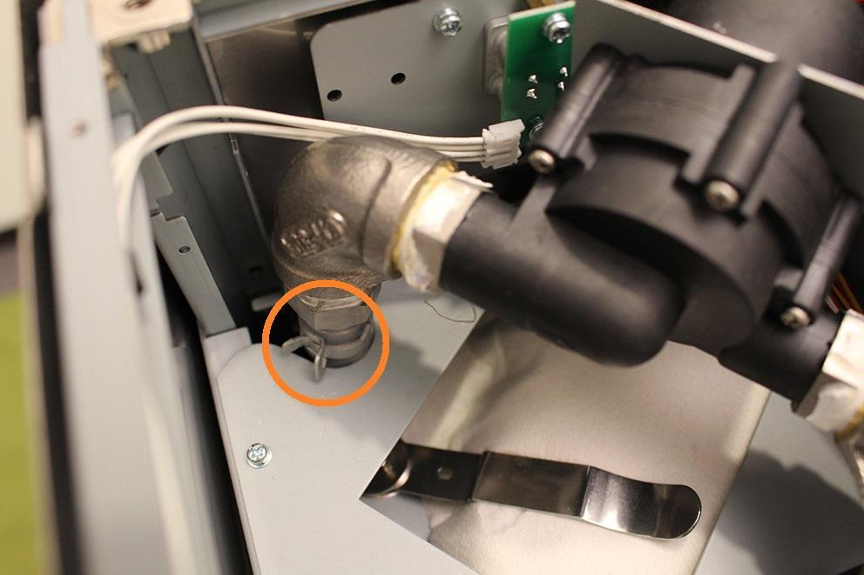

Remove the hose clamp from the interior of the machine.

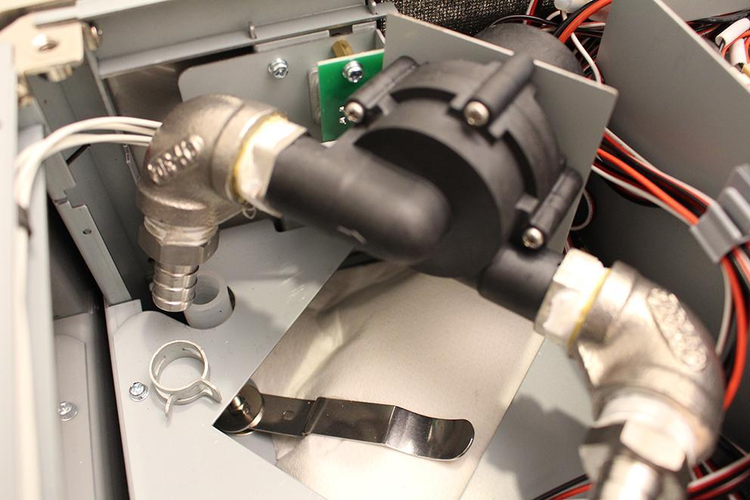

This is the plug of the pump.

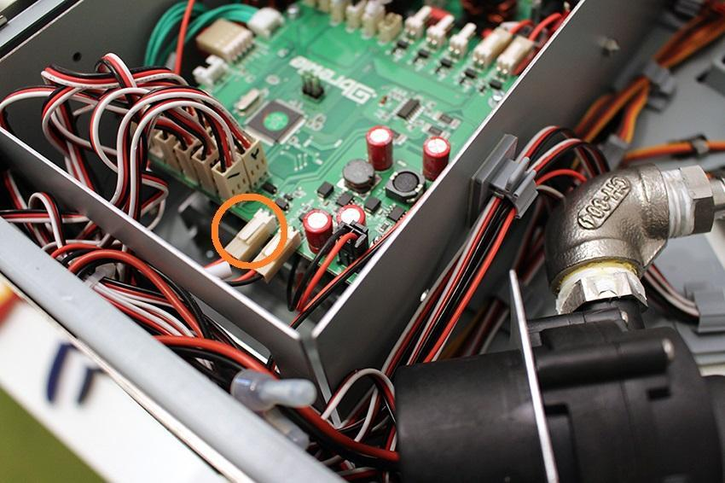

Pull off and remove it from the cable hole.

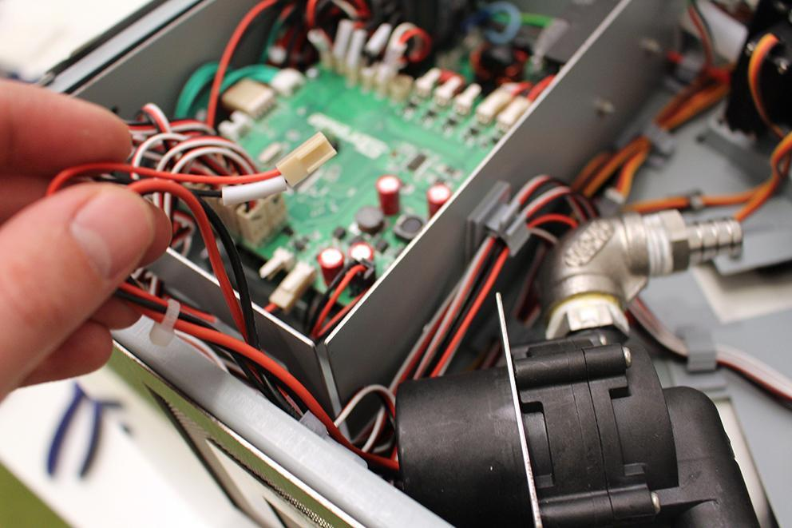

The pump is removable now.

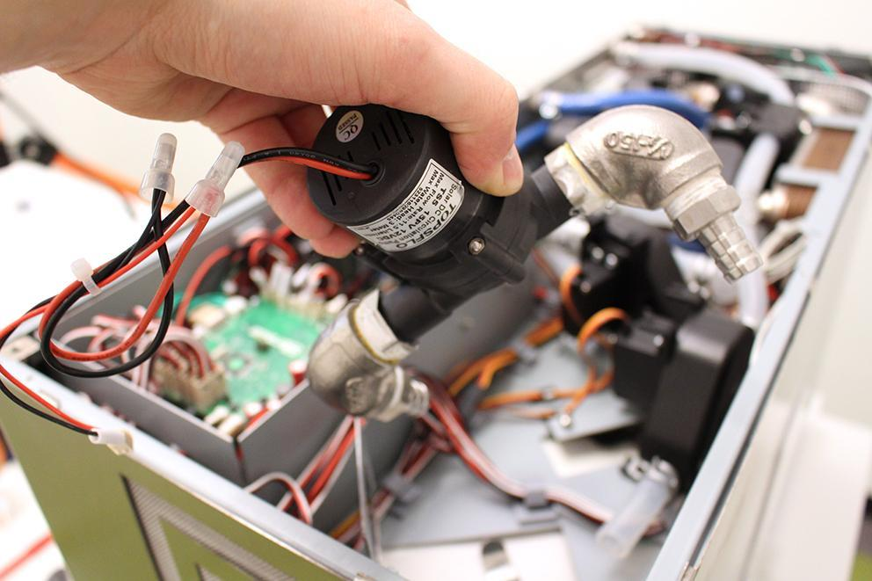

The plug of the button.

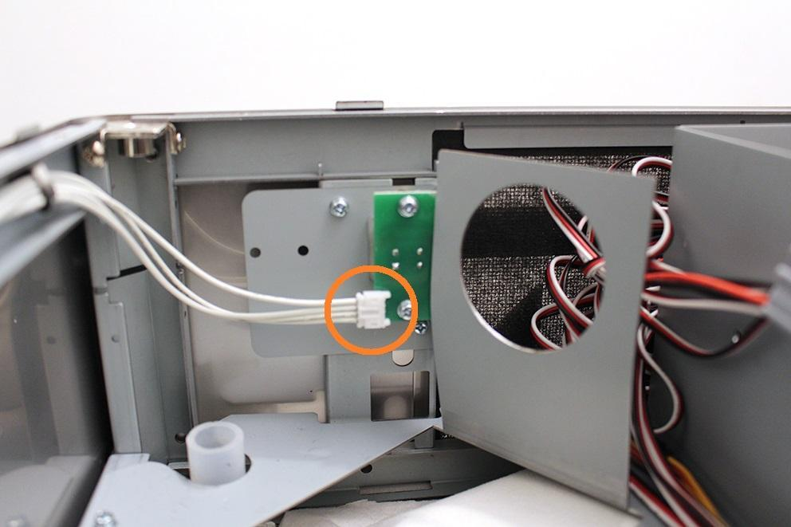

Disconnect the plug of the button. Unscrew the two indicated screws.

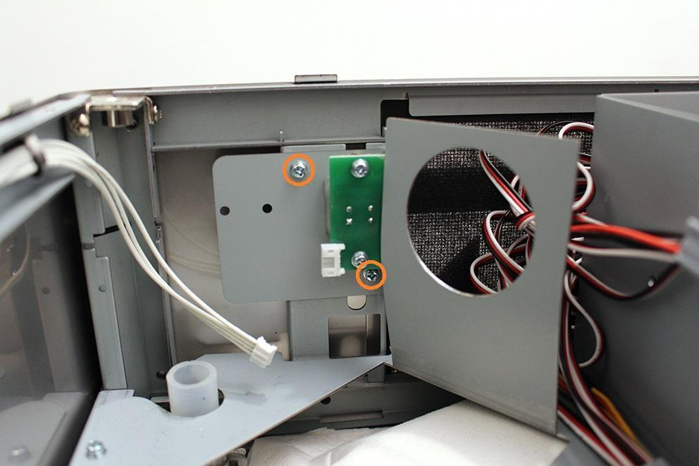

Now you can remove the button unit.

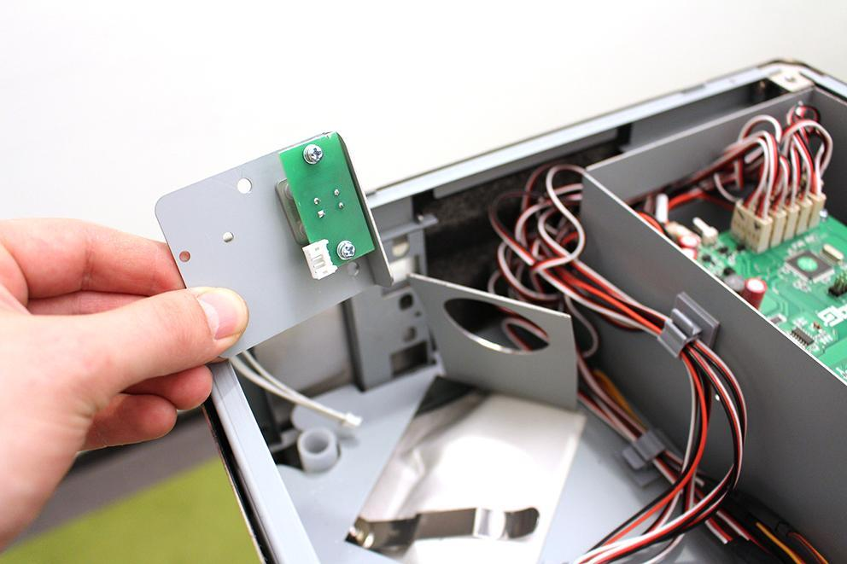

Replace the part.

Reassemble consists of the same steps in reverse.

Be careful with the silicone flange around the button while reassembling the button!

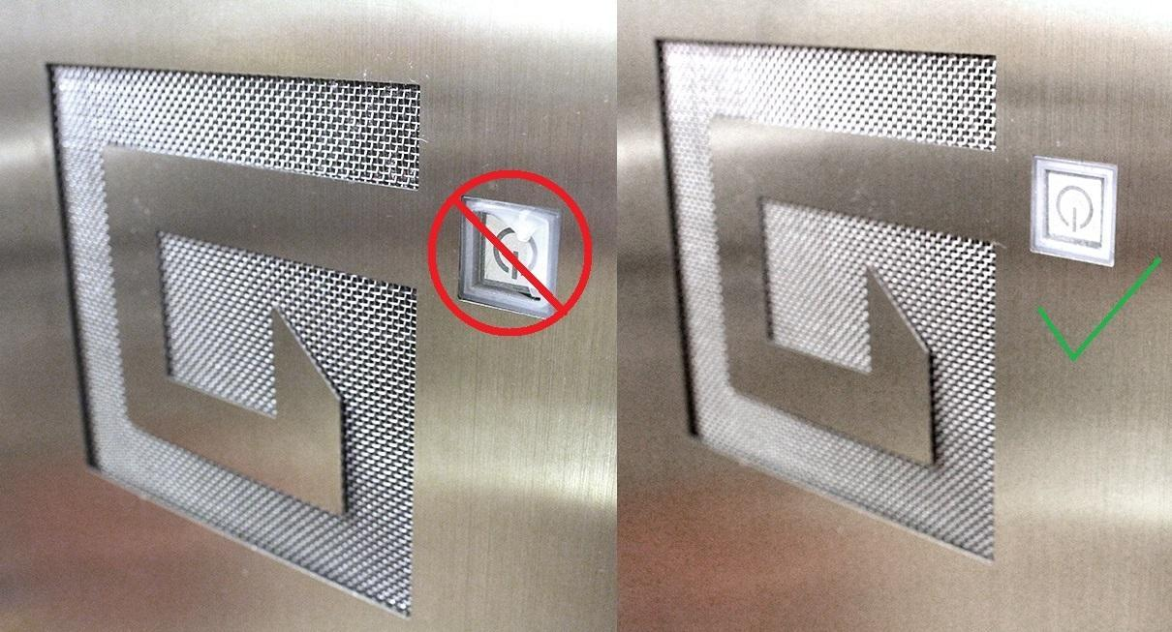

Make sure that the pumps are in the specified angle. Otherwise the pumps will not work properly. Use cable tie to fix the pump.

